Statistics 147 Assignment #5
Sarah Ruckman
SID: 7194
Section 002
November 22, 2017
USING SAS
- SAS Question 1
  - Read in and print out the data using nested Do loops. (Be sure to give your columns the appropriate names using if-then-else structures!) (Done as part of Assignment #4.) (1 pt)
SAS Code:
options ls = 70 ps = 55 nocenter formdlim = '*';
/* ls = linesize, ps = pagesize, nocenter = justifies output, formdlim = overrides the internal page breaks
and replaces them with the designated symbol */
/* Create titles */
title1 'Statstics 147 Assignment #5';
title2 'Fall 2017';
title3 'Sarah Ruckman';
title4 'Section 002';
title5 'SAS Question 1';
/*Read infile using do loops do rows and then columns and there are 2 lines of headers*/
/*Create temporary SAS dataset called geysers*/
data geysers;
infile "C:\Users\sarah\Downloads\geysers_f17.dat" firstobs = 3;
do rows = 1 to 10;
do col = 1 to 3;
/*Create if then else statements to label the columns and end with an else statement*/
if col = 1 then name = 'Old Faithful';
else if col = 2 then name = 'Grand Geysir';
else name = 'Strokkur ';
/*input the values and add @@ to denote that the values are on the same line*/
input values @@;
/*Output the results*/
output;
/*Close both loops*/
end;
end;
/*Sort the data by column using proc sort*/
proc sort;
by name;
/*Print as check without observations*/
proc print noobs;
run;
quit;

Output:

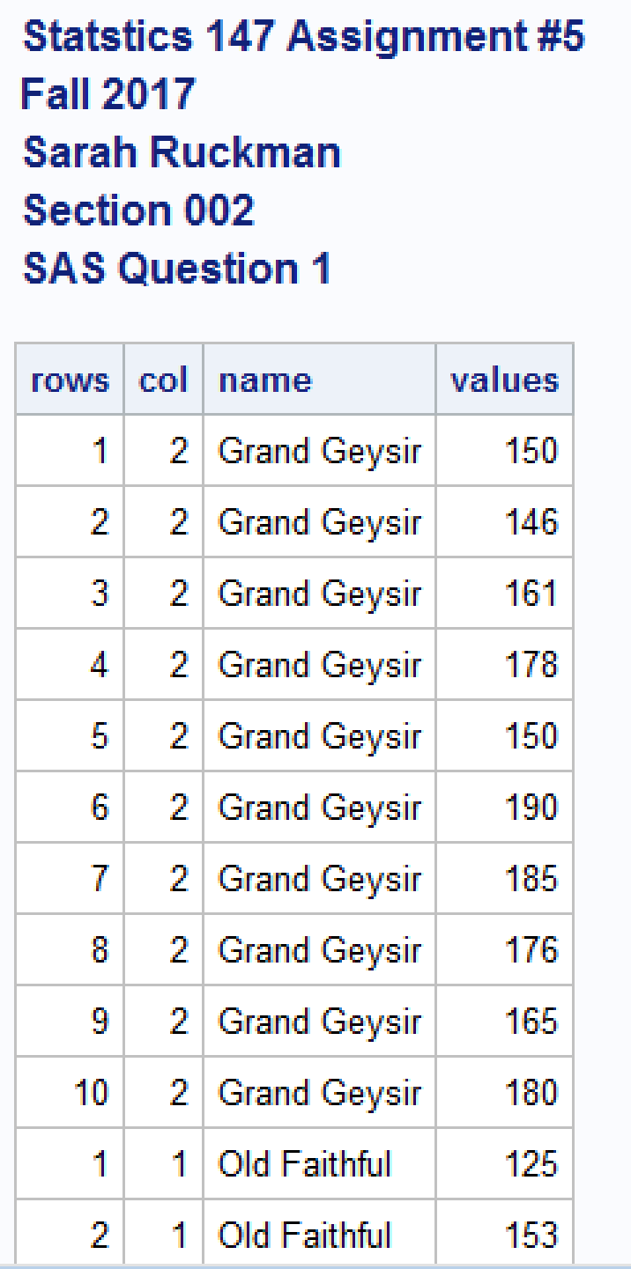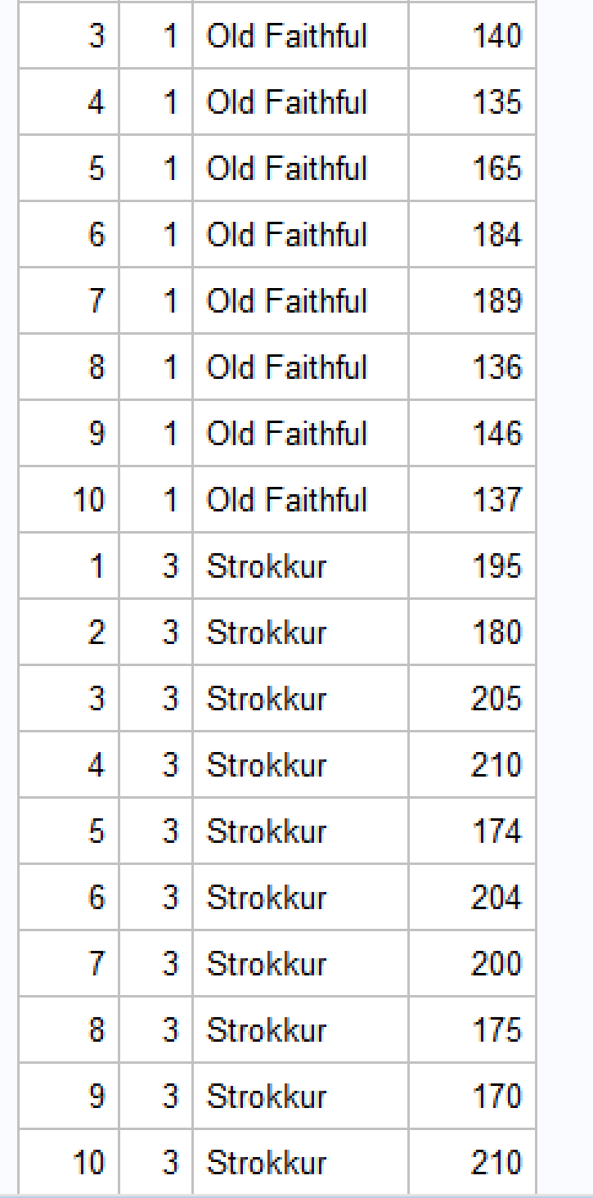

  - Test whether the true mean eruption height of Grand Geysir is 175 feet. Use α= 0.05. (3 pts)
SAS Code:
options ls = 70 ps = 55 nocenter formdlim = '*';
/* ls = linesize, ps = pagesize, nocenter = justifies output, formdlim = overrides the internal page breaks
and replaces them with the designated symbol */
/* Create titles */
title1 'Statstics 147 Assignment #5';
title2 'Fall 2017';
title3 'Sarah Ruckman';
title4 'Section 002';
title5 'SAS Question 1';
/*Read infile using do loops do rows and then columns and there are 2 lines of headers*/
/*Create temporary SAS dataset called geysers*/
data geysers;
infile "C:\Users\sarah\Downloads\geysers_f17.dat" firstobs = 3;
do rows = 1 to 10;
do col = 1 to 3;
/*Create if then else statements to label the columns and end with an else statement*/
if col = 1 then name = 'Old Faithful';
else if col = 2 then name = 'Grand Geysir';
else name = 'Strokkur ';
/*input the values and add @@ to denote that the values are on the same line*/
input values @@;
/*Output the results*/
output;
/*Close both loops*/
end;
end;
/*Sort the data by column using proc sort*/
proc sort;
by name;
/*Print as check without observations*/
proc print noobs;
/*Create temporary data set onlyGG*/
data onlyGG;
/*Use set and if command to create dataset with only GG*/
set geysers;
if col =2;
/*Transform the mean to zero*/
newmean = values - 175;
/*Print as a check*/
proc print noobs;
/*Use proc means to generate test information t, t test, and var new mean*/
proc means n mean t probt;
var newmean;
run;
quit;

Output:
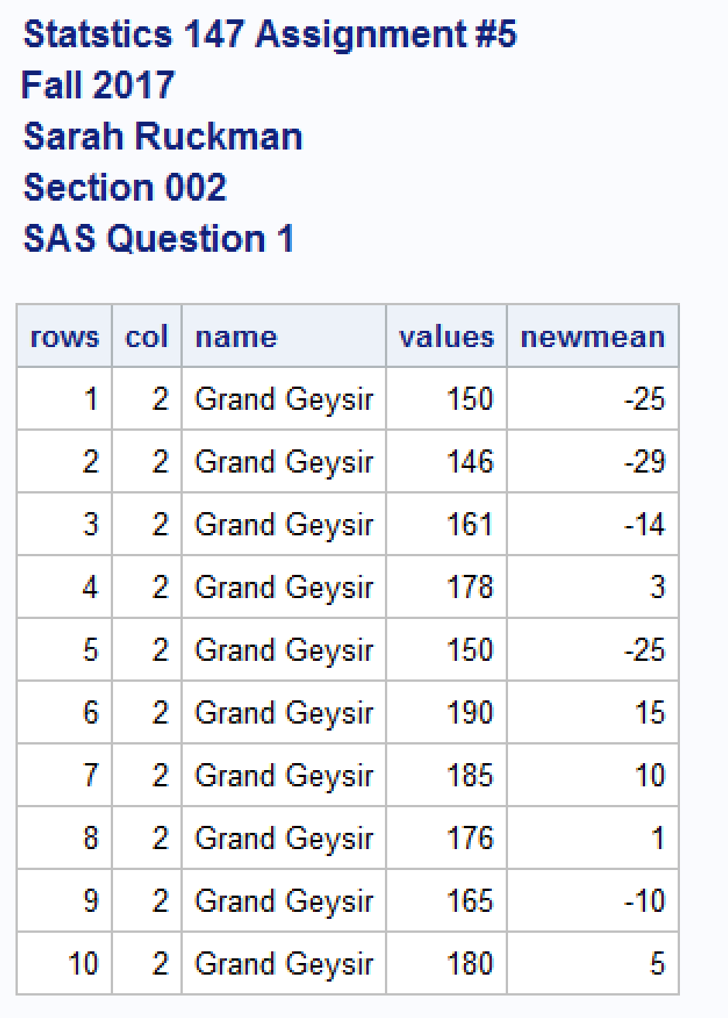
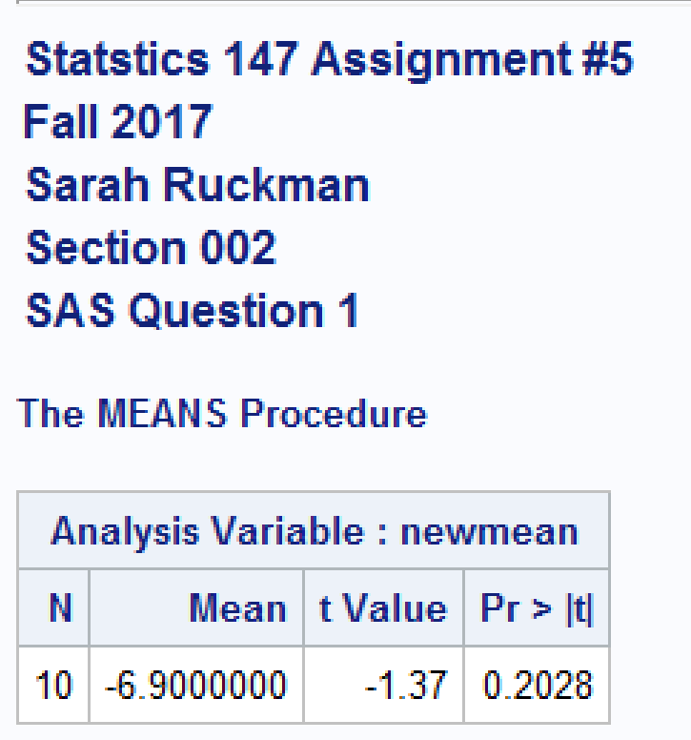

Let μ_{GG} = true mean eruption height of Grand Geysir
    - 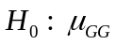 = 175 feet
    - 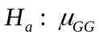 ≠ 175 feet
    - p-value = 0.2028
    - Rejection Region: Reject H₀ if p-value < α = 0.05
    - Conclusion: Since the p-value = 0.2028 is greater than α = 0.05, we do not reject H₀ and we cannot conclude that the true mean eruption height of Grand Geysir is significantly different from 175 feet.
  - Find and interpret a 98% confidence interval for the true mean eruption height for Grand Geysir. (2 pts)
SAS Code:
options ls = 70 ps = 55 nocenter formdlim = '*';
/* ls = linesize, ps = pagesize, nocenter = justifies output, formdlim = overrides the internal page breaks
and replaces them with the designated symbol */
/* Create titles */
title1 'Statstics 147 Assignment #5';
title2 'Fall 2017';
title3 'Sarah Ruckman';
title4 'Section 002';
title5 'SAS Question 1';
/*Read infile using do loops do rows and then columns and there are 2 lines of headers*/
/*Create temporary SAS dataset called geysers*/
data geysers;
infile "C:\Users\sarah\Downloads\geysers_f17.dat" firstobs = 3;
do rows = 1 to 10;
do col = 1 to 3;
/*Create if then else statements to label the columns and end with an else statement*/
if col = 1 then name = 'Old Faithful';
else if col = 2 then name = 'Grand Geysir';
else name = 'Strokkur ';
/*input the values and add @@ to denote that the values are on the same line*/
input values @@;
/*Output the results*/
output;
/*Close both loops*/
end;
end;
/*Sort the data by column using proc sort*/
proc sort;
by name;
/*Print as check without observations*/
proc print noobs;
/*Create temporary data set onlyGG*/
data onlyGG;
/*Use set and if command to create dataset with only GG*/
set geysers;
if col =2;
/*Transform the mean to zero*/
newmean = values - 175;
/*Print as a check*/
proc print noobs;
/*Use proc means to generate test information t, t test, and var new mean*/
proc means n mean t probt;
var newmean;
/*Use proc means to create confidence interval for GG and change alpha to 0.02*/
proc means n mean clm alpha=0.02;
by name;
run;
quit;

Output:
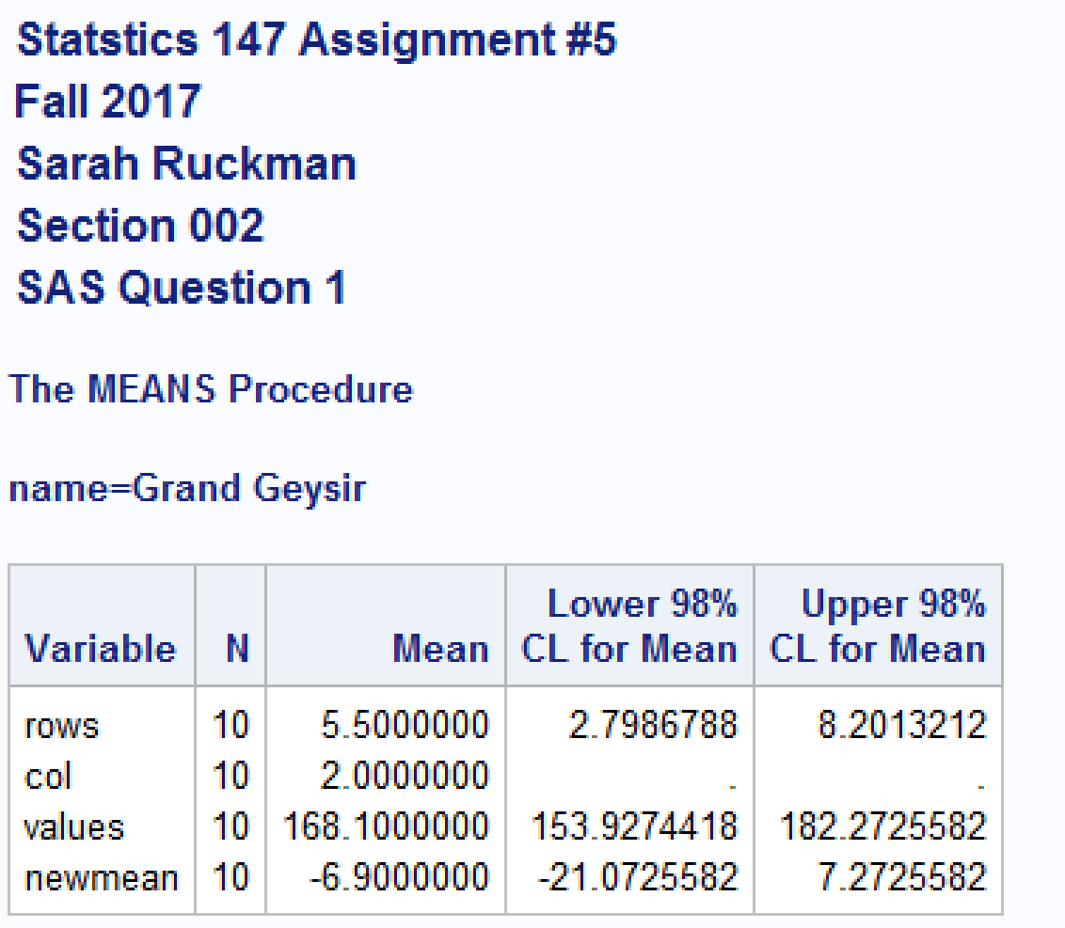

LIMITS: (153.9274418, 182.2725582)

INTERPRETATION:
One can be 98% confident that the true mean eruption height for the Grand Geysir lies between 153.9274418 and 182.2725582 feet.

  - Perform the appropriate test(s) of hypothesis to determine whether one can conclude there is a significant difference in mean eruption height between Grand Geysir and Strokkur.Use α = 0.05. (6 pts)
SAS Code:
options ls = 70 ps = 55 nocenter formdlim = '*';
/* ls = linesize, ps = pagesize, nocenter = justifies output, formdlim = overrides the internal page breaks
and replaces them with the designated symbol */
/* Create titles */
title1 'Statstics 147 Assignment #5';
title2 'Fall 2017';
title3 'Sarah Ruckman';
title4 'Section 002';
title5 'SAS Question 1';
/*Read infile using do loops do rows and then columns and there are 2 lines of headers*/
/*Create temporary SAS dataset called geysers*/
data geysers;
infile "C:\Users\sarah\Downloads\geysers_f17.dat" firstobs = 3;
do rows = 1 to 10;
do col = 1 to 3;
/*Create if then else statements to label the columns and end with an else statement*/
if col = 1 then name = 'Old Faithful';
else if col = 2 then name = 'Grand Geysir';
else name = 'Strokkur ';
/*input the values and add @@ to denote that the values are on the same line*/
input values @@;
/*Output the results*/
output;
/*Close both loops*/
end;
end;
/*Sort the data by column using proc sort*/
proc sort;
by name;
/*Print as check without observations*/
proc print noobs;
/*Create temporary data set onlyGG*/
data onlyGG;
/*Use set and if command to create dataset with only GG*/
set geysers;
if col =2;
/*Transform the mean to zero*/
newmean = values - 175;
/*Print as a check*/
proc print noobs;
/*Use proc means to generate test information t, t test, and var new mean*/
proc means n mean t probt;
var newmean;
/*Use proc means to create confidence interval for GG and change alpha to 0.02*/
proc means n mean clm alpha=0.02;
by name;
/*Create new temporary SAS dataset called bothGGS*/
data bothGGS;
/*Use set command to call back to the original dataset and if statement to grab only GG and S*/
set geysers;
if col not=1;
/*Print as check*/
proc print noobs;
/*Use proc ttest to generate a test of variances and t test if approporiate*/
proc ttest;
class col;
var values;
run;
quit;
Output:
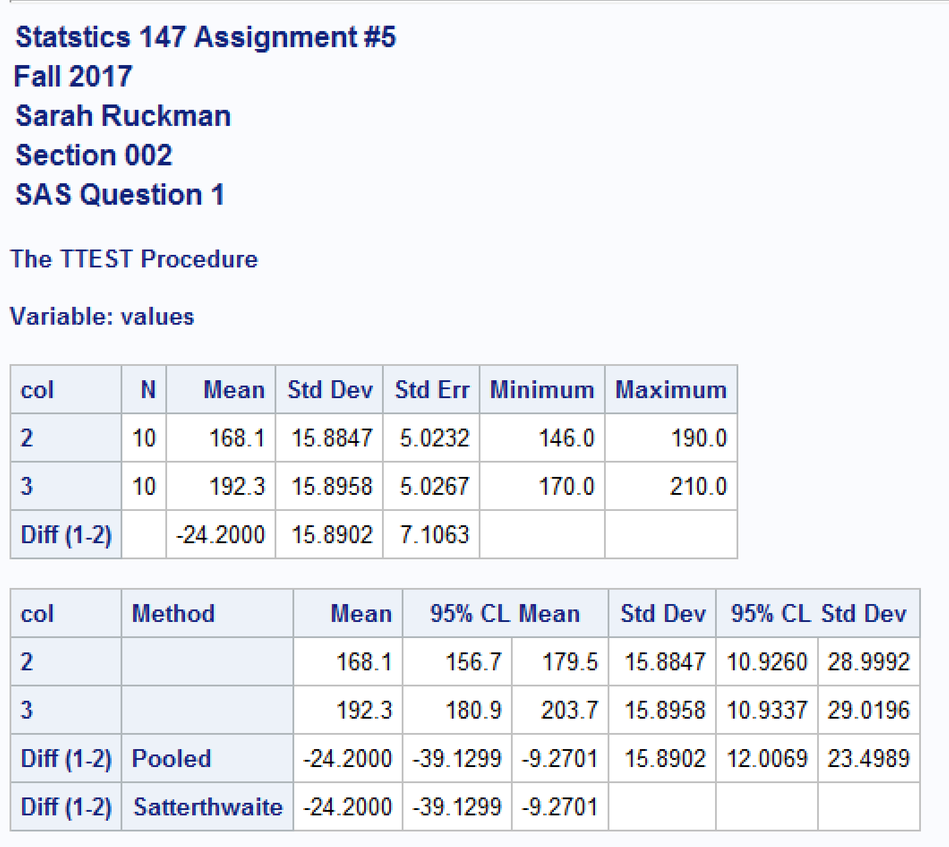
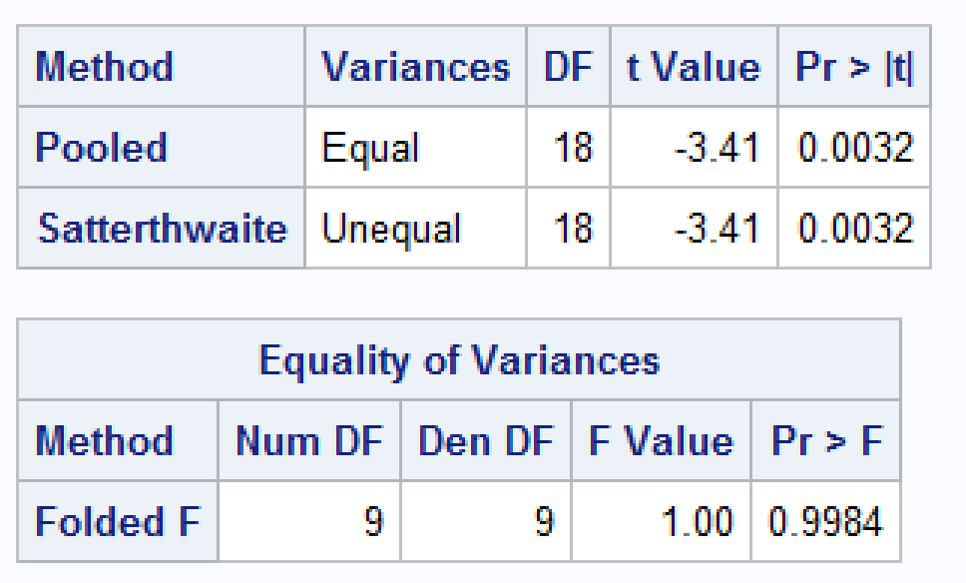

Let µ_{GG}= true mean eruption height for Grand Geysir.
Let µ_{S} = true mean eruption height for Strokkur.
Let 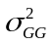= population variance of the eruption height for Grand Geysir.
Let 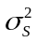= population variance of the eruption height for Grand Geysir.

First test for equality of variances:
- 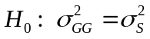
- 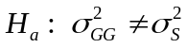
- p-value = 0.9984
- Rejection Region: Reject H₀ if p-value < α = 0.05
- Conclusion: Since the p-value = 0.9984, which is greater than α = 0.05, we do not reject H₀ and it is reasonable to assume equality of variances.

Now test means:
- 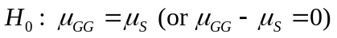
- 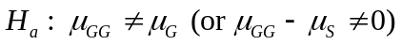
- p-value = 0.0032
- Rejection Region: Reject H₀ if p-value < α = 0.05
- Conclusion: Since the p-value = 0.0032, which is less than α = 0.05, we reject H₀ and it is reasonable to assume a significant difference in the mean eruption heights between the Grand Geysir and Strokkur.

- SAS Question 2
  - Read in the data using an infile statement. (Do not use DO loops! Be sure to print your data as a check!) (This was done as part of Assignment #4.) (1 pt)
SAS Code:
options ls = 70 ps = 55 nocenter formdlim = '*';
/* ls = linesize, ps = pagesize, nocenter = justifies output, formdlim = overrides the internal page breaks
and replaces them with the designated symbol */
ods graphics off;
/*Turns off the extra graphs*/
/* Create titles */
title1 'Statstics 147 Assignment #5';
title2 'Fall 2017';
title3 'Sarah Ruckman';
title4 'Section 002';
title5 'SAS Question 2';
/*Create new dataset with infile statement for question 2*/
data dogdive;
infile "C:\Users\sarah\Downloads\dogdive_f17.dat" firstobs = 3;
/*input the variables Dog which is a character variable, Dive1, and Dive2*/
input Dog$ Dive1 Dive2;
/*Print the results without observation numbers*/
proc print noobs;
run;
quit;

Output:
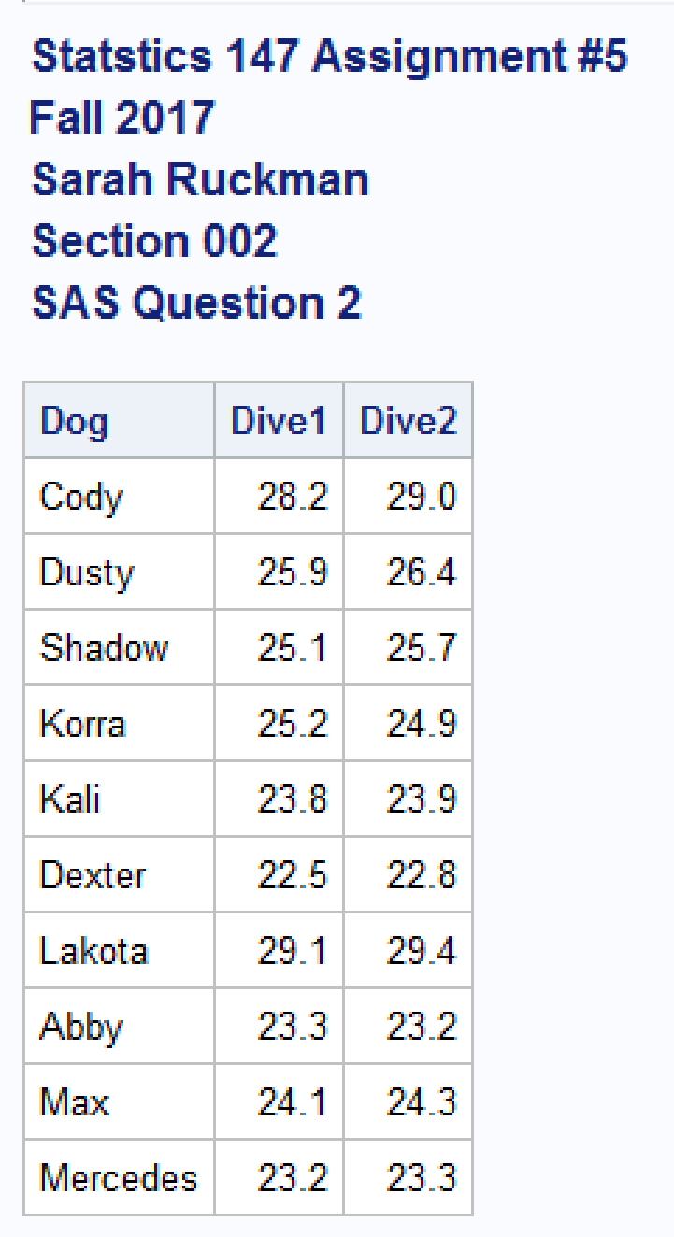

  - Perform the test of hypothesis to determine whether the mean dive distance for Dive1 is less than the mean dive distance for Dive2. Use α= 0.05. (4 pts)
SAS Code:
options ls = 70 ps = 55 nocenter formdlim = '*';
/* ls = linesize, ps = pagesize, nocenter = justifies output, formdlim = overrides the internal page breaks
and replaces them with the designated symbol */
ods graphics off;
/*Turns off the extra graphs*/
/* Create titles */
title1 'Statstics 147 Assignment #5';
title2 'Fall 2017';
title3 'Sarah Ruckman';
title4 'Section 002';
title5 'SAS Question 2';
/*Create new dataset with infile statement for question 2*/
data dogdive;
infile "C:\Users\sarah\Downloads\dogdive_f17.dat" firstobs = 3;
/*input the variables Dog which is a character variable, Dive1, and Dive2*/
input Dog$ Dive1 Dive2;
/*Print the results without observation numbers*/
proc print noobs;
/*Use the proc ttest with paired Dive1*Dive2 to test differences of means*/
/*Use the proc ttest with paired Dive1*Dive2 to test differences of means and use the sides option with L to test less than*/
proc ttest sides=L;
paired Dive1*Dive2;
run;
quit;

Output:
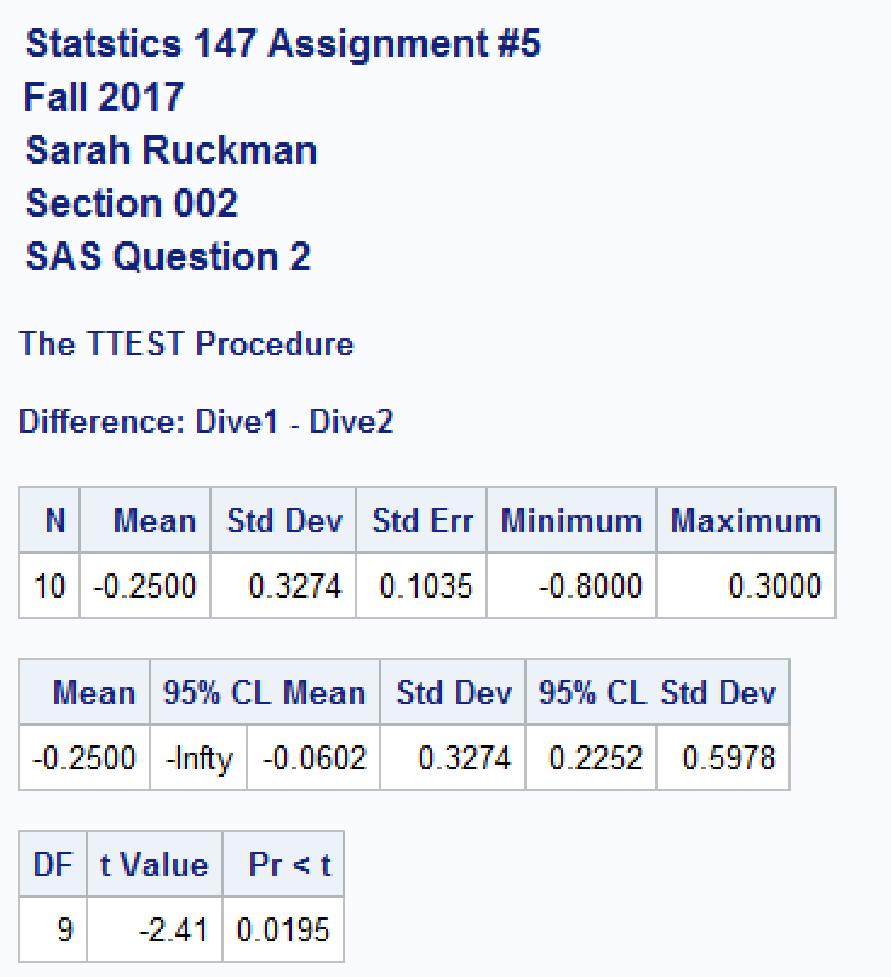

Let µ_{D} = population mean of the differences (Dive1 – Dive2)

- 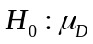= 0
- 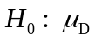< 0
- p-value = 0.0195
- Rejection Region: Reject H₀ if p-value < α = 0.05
- Conclusion: Since the p-value = 0.0195 is less than α = 0.05, we reject H₀, and it is reasonable to assume the mean dive distance for Dive1 is significantly less than the mean dive distance for Dive2.

USING R
- Refer to SAS Question 1.
  - Write the R code to read in and print out the data. Be sure to add the line(s) of code to make the columns accessible individually. (This was done as part of Assignment #4.) (1 pt)
R Code:
> #Statistics 147 Assignment 5
> #Fall 2017
> #Sarah Ruckman
> #Section 002
> #R Question 1
> #Use a read.table function to read in the data
>geysers<-read.table("C:\\Users\\sarah\\Downloads\\geysers_f17.dat", header=TRUE,skip=1)
> #Print as check
> geysers
OF GG S
1 125 150 195
2 153 146 180
3 140 161 205
4 135 178 210
5 165 150 174
6 184 190 204
7 189 185 200
8 136 176 175
9 146 165 170
10 137 180 210
> #Attach the columns to be used separately
> attach(geysers)
> #Use names function to see names
> names(geysers)
[1] "OF" "GG" "S"
> #Print as check
> OF
[1] 125 153 140 135 165 184 189 136 146 137
> GG
[1] 150 146 161 178 150 190 185 176 165 180
> S
[1] 195 180 205 210 174 204 200 175 170 210

  - Using R to generate the appropriate output, test whether the true mean eruption height for Old Faithful is greater than 145 feet. Use α = 0.05. (3 pts)
R Code:
> #Use t.test with the options OF, alternative="greater", mu = 145, and conf.level=0.95
> t.test(OF,alternative="greater",mu=145,conf.level=0.95)

One Sample t-test

data: OF
t = 0.87498, df = 9, p-value = 0.2022
alternative hypothesis: true mean is greater than 145
95 percent confidence interval:
138.4298 Inf
sample estimates:
mean of x
151
Let μ_{OF} = true mean eruption height for Old Faithful.

    - 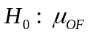= 145 feet
    - 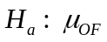 > 145 feet
    - p-value = 0.2022
    - Rejection Region: Reject H₀ if p-value < α = 0.05
    - Conclusion: Since the p-value = 0.2022 which is greater than α = 0.05, we do not reject H₀ and it is not reasonable to assume the true mean eruption height for Old Faithful is significantly greater than 145 feet.

  - Using R to generate the output, find and interpret a 99% confidence interval for the true mean eruption height of Strokkur. (3 pts)
R Code:
> #Use t.test to create a 99% conf.level with S as the variable
> t.test(S,alternative="two.sided",conf.level=0.99)

One Sample t-test

data: S
t = 38.256, df = 9, p-value = 2.83e-11
alternative hypothesis: true mean is not equal to 0
99 percent confidence interval:
175.964 208.636
sample estimates:
mean of x
192.3

LIMITS: (175.964, 208.636)

INTERPRETATION: One can be 99% confident that the true mean eruption height of Strokkur lies between 175.964 and 208.636 feet.

  - Using R to generate the appropriate output, perform the appropriate test(s) of hypothesis to determine whether one can conclude that the mean eruption height for Old Faithful team is significantly lower than the mean eruption height for Grand Geysir. Use α = 0.05. (6 pts)
R Code:
> #To test for significance of OF being lower than GG we need to test variances
> #Use var.test to test equal variances with OF, GG, ratio=1, alternative="two.sided", and conf.level=0.95
> var.test(OF,GG,ratio=1,alternative="two.sided",conf.level=0.95)

F test to compare two variances

data: OF and GG
F = 1.8636, num df = 9, denom df = 9, p-value = 0.3675
alternative hypothesis: true ratio of variances is not equal to 1
95 percent confidence interval:
0.4628865 7.5027554
sample estimates:
ratio of variances
1.863578

> #Since the p-value = 0.3675 is greater than 0.05 I can continue to find if my means are different
> #Use t.test(OF,GG,alternative="less",var.equal=TRUE,conf.level=0.95)
> t.test(OF,GG,alternative="less",var.equal=TRUE,conf.level=0.95)

Two Sample t-test

data: OF and GG
t = -2.0117, df = 18, p-value = 0.02973
alternative hypothesis: true difference in means is less than 0
95 percent confidence interval:
-Inf -2.360006
sample estimates:
mean of x mean of y
151.0 168.1

Let µ_{OF} = true mean eruption height for Old Faithful.
Let µ_{GG} = true mean eruption height for Grand Geysir.
Let 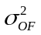= population variance of the eruption height for Old Faithful
Let = population variance of the eruption height for Grand Geysir.

First test for equality of variances:
- 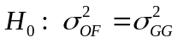
- 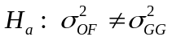
- p-value = 0.3675
- Rejection Region: Reject H₀ if p-value < α = 0.05
- Conclusion: Since the p-value = 0.3675 is greater than α = 0.05, we do not reject H₀, and it is reasonable to assume equality of variances.

Now test means:
- 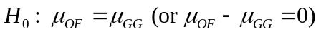
- p-value = 0.02973
- Rejection Region: Reject H₀ if p-value < α = 0.05
- Conclusion: Since the p-value = 0.02973 which is less than α = 0.05, we reject H₀, and it is reasonable to assume that Old Faithful is significantly lower in true mean eruption height than the Grand Geysir.

- Refer to SAS Question 2.
  - Write the R code to read in and print out the data. Be sure to add the line(s) of code to make the columns accessible individually. (This was done as part of Assignment #4.) (1 pt)
R Code:
> #R Question 2
> #Read in and print out the data using an read.table statement and skip function
>dogdive<-read.table("C:\\Users\\sarah\\Downloads\\dogdive_f17.dat", header=TRUE,skip=1)
> #Print as check
> dogdive
Dog Dive1 Dive2
1 Cody 28.2 29.0
2 Dusty 25.9 26.4
3 Shadow 25.1 25.7
4 Korra 25.2 24.9
5 Kali 23.8 23.9
6 Dexter 22.5 22.8
7 Lakota 29.1 29.4
8 Abby 23.3 23.2
9 Max 24.1 24.3
10 Mercedes 23.2 23.3
> #Use attach function to separate the columns
> attach(dogdive)
> #Use names function to see the names
> names(dogdive)
[1] "Dog" "Dive1" "Dive2"
> #Print as check
> Dog
[1] Cody Dusty Shadow Korra Kali Dexter Lakota Abby
[9] Max Mercedes
Levels: Abby Cody Dexter Dusty Kali Korra Lakota Max Mercedes Shadow
> Dive1
[1] 28.2 25.9 25.1 25.2 23.8 22.5 29.1 23.3 24.1 23.2
> Dive2
[1] 29.0 26.4 25.7 24.9 23.9 22.8 29.4 23.2 24.3 23.3

  - Using R to generate the appropriate output, perform the test of hypothesis to determine whether there is a significant difference in mean dive distance between the two dives. Use α = 0.05. (4 pts)
R Code:
> #Use t.test to test whether the differences is significantly different (two.sided)
> #The data is paired and that option should be selected
>#Use t.test(Dive1,Dive2,alternative="two.sided",paired=TRUE,conf.level=0.95)
> t.test(Dive1,Dive2,alternative="two.sided",paired=TRUE,conf.level=0.95)

Paired t-test

data: Dive1 and Dive2
t = -2.4143, df = 9, p-value = 0.03897
alternative hypothesis: true difference in means is not equal to 0
95 percent confidence interval:
-0.48424222 -0.01575778
sample estimates:
mean of the differences
-0.25

Let µ_{D} = population mean of the differences (Dive1 – Dive2)
- = 0
- ≠ 0
- p-value = 0.03897
- Rejection Region: Reject H₀ if p-value < α = 0.05
- Conclusion: Since the p-value = 0.03897 which is less than α = 0.05, we reject H₀, and it is reasonable to assume there is a significant difference in mean dive distances between the two dives.

